6th Annual International Fair
Hamlin Elementary School
Friday, February 21, 2020
5:30 – 8:00 PM in the Gymnasium!
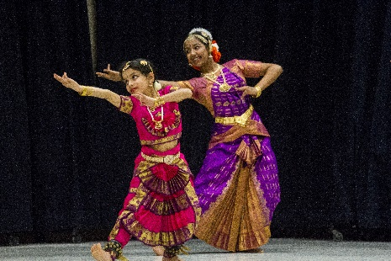
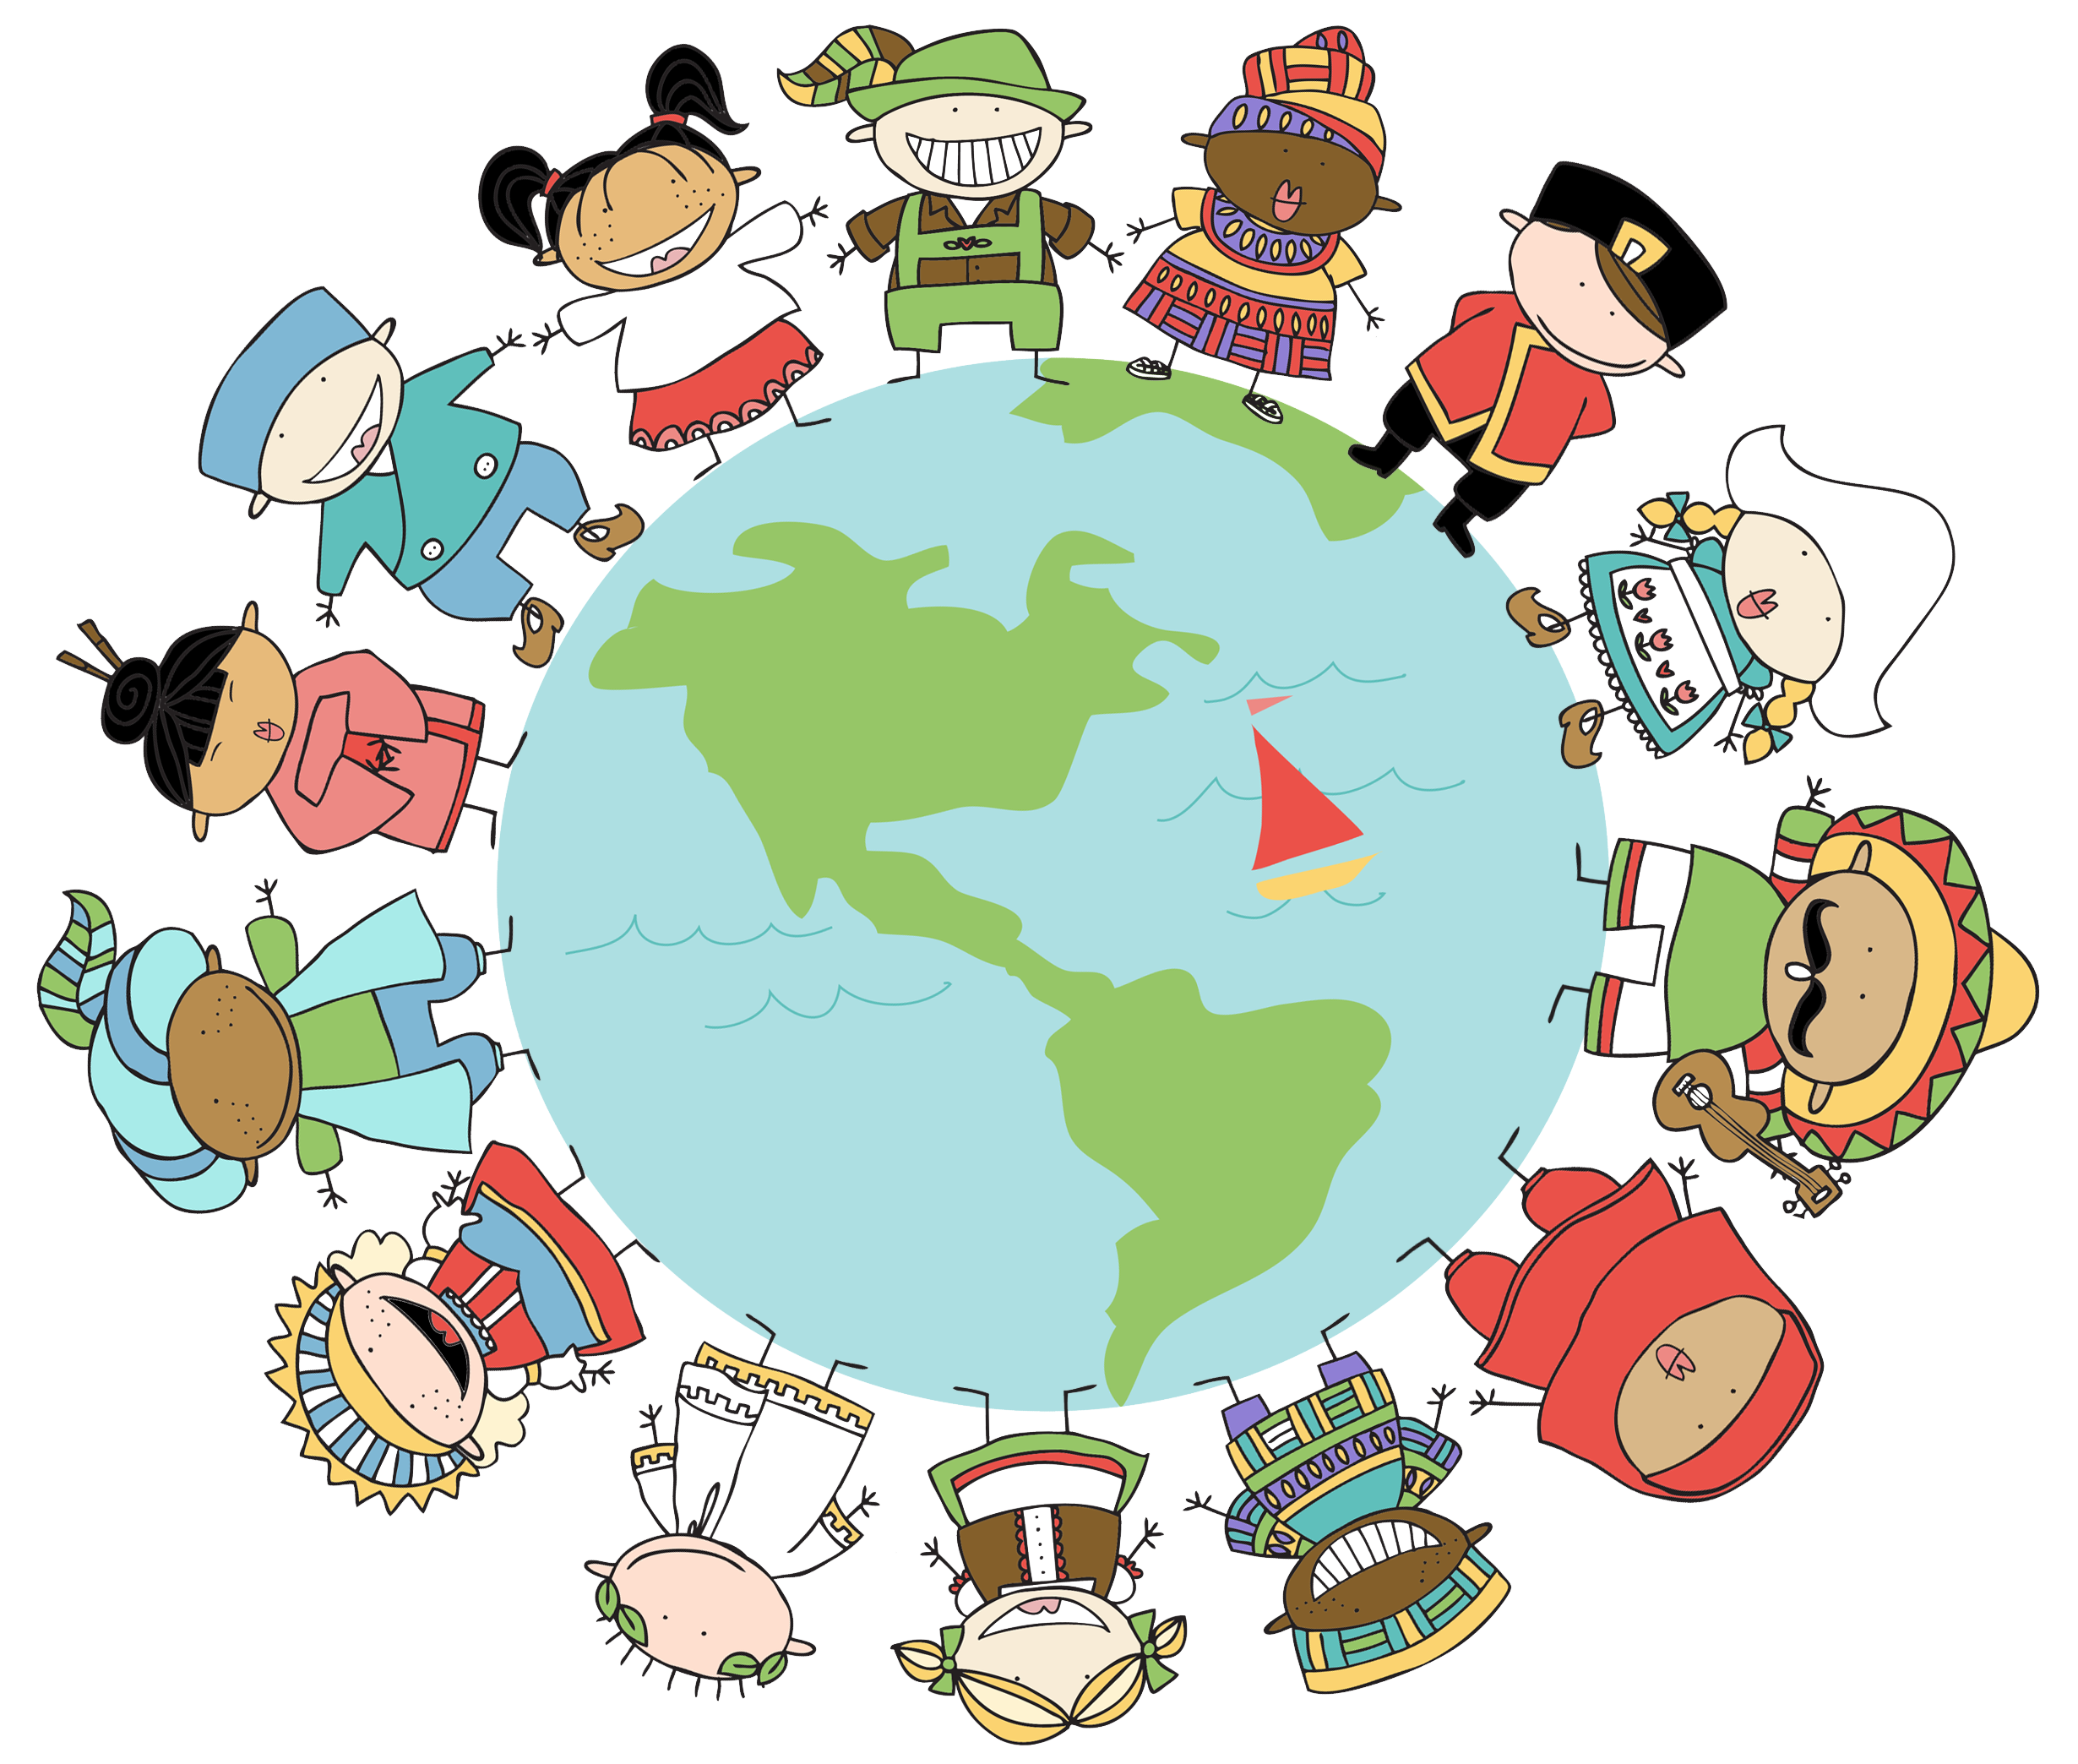
Music
Culture
Heritage
Food
Dancing
Language

This event is free!
Parents must stay with their child/children.
Parking available at Faith Church and St. Mark’s Orthodox Church.
A shuttle bus will be provided

